CONCEPTUAL FRAMEWORK OF ACCOUNTING

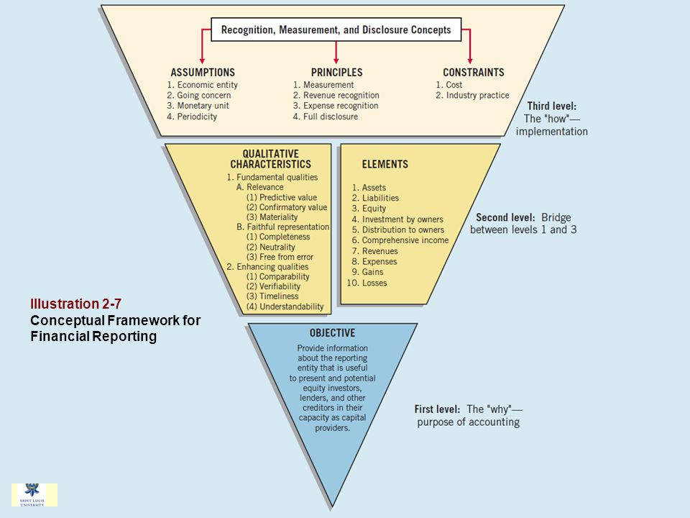

Definition of conceptual framework
A conceptual framework is a coherent system of objective and fundamental principles.
A framework which prescribes the nature, functions and limits of financial accounting and financial statements.
- Purpose of conceptual framework
The Framework's purpose is to assist the IASB in developing and revising IFRSs that are based on consistent concepts, to help preparers to develop consistent accounting policies for areas that are not covered by a standard or where there is choice of accounting policy, and to assist all parties to understand and interpret IFRS
In the absence of a Standard or an Interpretation that specifically applies to a transaction, management must use its judgment in developing and applying an accounting policy that results in information that is relevant and reliable. In making that judgment, IAS 8.11 requires management to consider the definitions, recognition criteria, and measurement concepts for assets, liabilities, income, and expenses in the Framework.
- Qualitative characteristics of financial information
Qualitative characteristics are the attributes that make information provided in financial statements
The following are the qualitative characteristics;
- Relevance
Information provided by financial statements needs to be relevant
Information is relevant if;
- It has the ability to influence the economic decision of the users
- It is provided in time to influence those decisions.
- It is material
Relevant information has predictive or confirmatory value
- Predictive value enables users to evaluate or assess past, present or future events
- Confirmatory value helps users to confirm or correct past evaluation and assessments
Materiality
Materiality is an entity-specific aspect of relevance based on the nature or magnitude (or both) of the items to which the information relates in the context of an individual entity's financial report
Information is material if its omission or misstatement could influence the economic decision of users taken on the basis of the financial statements.
- Faithful representation
General purpose financial reports represent economic phenomena in words and numbers. To be useful, financial information must not only be relevant, it must also represent faithfully the phenomena it purports to represent. Faithful representation means representation of the substance of an economic phenomenon instead of representation of its legal form only.

A faithful representation seeks to maximize the underlying characteristics of:
- Completeness
- Neutrality
- Free from error

- Enhancing qualities
Qualitative characteristics that enhance the usefulness of information that is relevant and faithfully represented are;
- Comparability,
- Verifiability,
- Timeliness
- understandability
Understandability Comparability
Information about a reporting entity is more useful if it can be compared with a similar information about other entities and with similar information about the same entity for another period or another date. Comparability enables users to identify and understand similarities in, and differences among, items.
Verifiability
Verifiability helps to assure users that information represents faithfully the economic phenomena it purports to represent. Verifiability means that different knowledgeable and independent observers could reach consensus, although not necessarily complete agreement, that a particular depiction is a faithful representation.
Timeliness
Timeliness means that information is available to decision-makers in time to be capable of influencing their decisions.
Understandability
Classifying, characterising and presenting information clearly and concisely makes it understandable. While some phenomena are inherently complex and cannot be made easy to understand, to exclude such information would make financial reports incomplete and potentially misleading. Financial reports are prepared for users who have a reasonable knowledge of business and economic activities and who review and analyse the information with diligence.

- Elements of financial statements

The elements directly related to financial position (balance sheet) are:
- Assets
- Liabilities
- Equity
The elements directly related to performance (income statement) are:
- Income
- Expenses
The cash flow statement reflects both income statement elements and some changes in balance sheet elements.
Definitions of the elements relating to financial position
- Asset. An asset is a resource controlled by the entity as a result of past events and from which future economic benefits are expected to flow to the entity.
- Liability. A liability is a present obligation of the entity arising from past events, the settlement of which is expected to result in an outflow from the entity of resources embodying economic benefits.
- Equity. Equity is the residual interest in the assets of the entity after deducting all its liabilities.
- Definitions of the elements relating to performance
- Income. Income is increases in economic benefits during the accounting period in the form of inflows or enhancements of assets or decreases of liabilities that result in increases in equity, other than those relating to contributions from equity participants.
- Expense. Expenses are decreases in economic benefits during the accounting period in the form of outflows or depletions of assets or incurrences of liabilities that result in decreases in equity, other than those relating to distributions to equity participants.
The definition of income encompasses both revenue and gains. Revenue arises in the course of the ordinary activities of an entity and is referred to by a variety of different names including sales, fees, interest, dividends, royalties and rent. Gains represent other items that meet the definition of income and may, or may not, arise in the course of the ordinary activities of an entity. Gains represent increases in economic benefits and as such are no different in nature from revenue. Hence, they are not regarded as constituting a separate element in the IFRS Framework
The definition of expenses encompasses losses as well as those expenses that arise in the course of the ordinary activities of the entity. Expenses that arise in the course of the ordinary activities of the entity include, for example, cost of sales, wages and depreciation. They usually take the form of an outflow or depletion of assets such as cash and cash equivalents, inventory, property, plant and equipment. Losses represent other items that meet the definition of expenses and may, or may not, arise in the course of the ordinary activities of the entity. Losses represent decreases in economic benefits and as such they are no different in nature from other expenses. Hence, they are not regarded as a separate element in this Framework.
- Recognition, measurement and disclosure concepts
- recognition
(Principles: revenue recognition, income recognition, measurement and full disclosure)
Recognition is the process of incorporating in the balance sheet or income statement an item that meets the definition of an element and satisfies the following criteria for recognition:
It is probable that any future economic benefit associated with the item will flow to or from the entity; and
- The item's cost or value can be measured with reliability.
Based on these general criteria:
- An asset is recognised in the balance sheet when it is probable that the future economic benefits will flow to the entity and the asset has a cost or value that can be measured reliably.
- A liability is recognised in the balance sheet when it is probable that an outflow of resources embodying economic benefits will result from the settlement of a present obligation and the amount at which the settlement will take place can be measured reliably.
- Income is recognized in the income statement when an increase in future economic benefits related to an increase in an asset or a decrease of a liability has arisen that can be measured reliably. This means, in effect, that recognition of income occurs simultaneously with the recognition of increases in assets or decreases in liabilities (for example, the net increase in assets arising on a sale of goods or services or the decrease in liabilities arising from the waiver of a debt payable).
Expenses are recognized when a decrease in future economic benefits related to a decrease in an asset or an increase of a liability has arisen that can be measured reliably. This means, in effect, that recognition of expenses occurs simultaneously with the recognition of an increase in liabilities or a decrease in assets (for example, the accrual of employee entitlements or the depreciation of equipment).
Measurement of the elements of financial statements
- Measurement
Assumptions: monetary unit, going concern, economic entity and periodicity
Measurement involves assigning monetary amounts at which the elements of the financial statements are to be recognised and reported.
The IFRS Framework acknowledges that a variety of measurement bases are used today to different degrees and in varying combinations in financial statements, including:
- Historical cost
- Current cost
- Net realisable (settlement) value
- Present value (discounted)
Historical cost is the measurement basis most commonly used today, but it is usually combined with other measurement bases. The IFRS Framework does not include concepts or principles for selecting which measurement basis should be used for particular elements of financial statements or in particular circumstances. Individual standards and interpretations do provide this guidance, however.
Constraints
Cost
Industry practice

